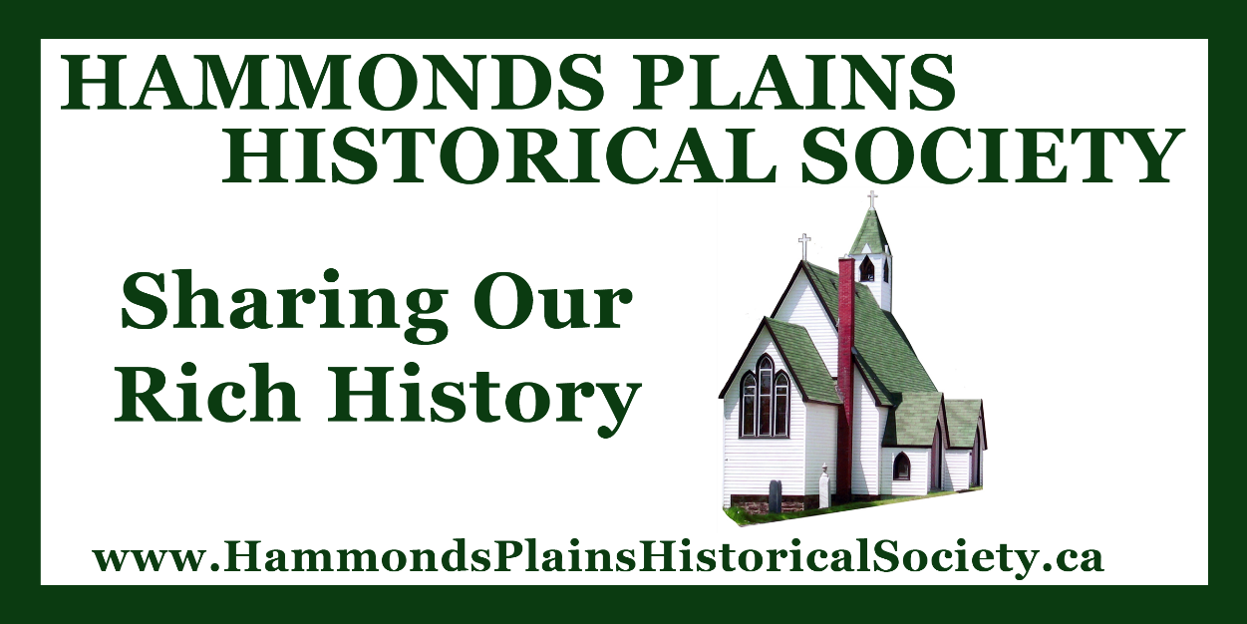
Hammonds Plains Historical Society

Strategic Plan 2021-26

Introduction:
This strategic plan has been developed by the Board of Directors of the Hammonds Plains Historical Society to provide goals and aims for the society, with the targeted time frame of 5 years (2021-26). It was created based on the progress from the previous 5 year plan (2014-19).
It should be noted that the plan was approved in November 2019, but due to the impact of COVID-19 little opportunity was afforded to work towards the goals of the plan during 2020 so the plan was revised to cover the 2021-26 time frame.
Background:
The Hammonds Plains Historical Society was established in 2010, after a yearlong series of planning meetings of original society members (Christina Parker, Cathy Munroe, Heather Kelly, Dave Haverstock, Joyce Evans), who saw the need to promote the history of the community.
We are a registered member of the Nova Scotia Joint Stocks and have a set of by-laws which outlines our governance. We have an eight member Board of Directors, which meets once a month. Membership to the society is open to any interested individual, with an annual $10 membership fee.
Achievements:
Since its inception, the Hammonds Plains Historical Society has enjoyed an array of successful achievements, including:
- Hosting of 5 general meeting per year, which include a presentation of local history.
- Creation of display boards, used to promote Hammonds Plains history.
- Distribution of society newsletters at each of the general meetings.
- Initiation of an Oral History Project, in which seniors are interviewed (taped) about their memories of growing up in the community.
- The construction of a promotion roadside sign, in front of Uplands Park.
- Creation of web page (hammondsplainshistoricalsociety.ca) and Facebook site.
- Obtaining a storage area for society resources at the Hammonds Plains Community Center.
- Researching and compiling PowerPoint presentations on a variety of Hammonds Plains Historical topics.
Our Vision:
To gather, preserve and share the rich history of Hammonds Plains and surrounding area, with any and all interested people.
Our Goals:
- To acquire, maintain, enhance and/or restore real and personal property of significant historical value in Nova Scotia.
- To publish information, exhibit, display and promote the public awareness and enjoyment of real and personal property & significant historical value in Nova Scotia.
- To work in conjunction with other groups, individuals and organizations who share goals in common with this society.
- To seek governmental assistance of any nature including municipal, provincial and federal government agencies to further the objectives of the society and to coordinate in affiliation with and assist any such agency including the goal of the society.
- To obtain funding from the public at large through direct gifts or various fund raising techniques to achieve the goal of the society.
Our Strategies and Action Steps:
Strategy | Action Steps | Completion | Statement of Progress
- To maintain and sustain General Meetings & Presentations | - To determine technology needs at HPCC.  - Take steps to achieve more efficient audio visual aids at HPCC.  - To maintain 5 meetings & presentations per year.  - To maintain a suggestion binder for new ideas, at each of the general meetings.  - To encourage a range of speakers for presentations at general meetings.  - To encourage active participation at meetings.  - To review meeting structure to determine streamlining of meetings. | May 2026 | - COVID had a major impact on the frequency and format of meetings during 2020-23.  - Despite COVID, the standard of 5 general meetings per year was achieved.  - Technology needs were reviewed and a list was made of needs including: cordless mic, receiver, mixer and speakers (to aid in presentations).  - Suggestion Binder was created and provided at general meetings.  - An updated list of potential topics for future presentations was generated. Trivia Nights and Photo Study sessions were introduced and went over with positive reviews.  - Meetings were streamlined with the elimination of approval of minutes.  - Introduction of Zoom option for meetings (as result of COVID restrictions).  - Purchase of portable sound system and lap top.
- To review resources to keep up with technology | - To review software needs.  - To review web page.  - To explore sound system options.  - To purchase a cordless mic to use for presentations.  - To explore tagging our photos.  - To explore how best to use google applications.  - To do an annual review of technological needs.  - To apply for grants to cover technological needs. | May 2026 | - Technology needs were reviewed and identified.  - Purchase of portable sound system was achieved through monies obtained from Bay Treasurer Chest Honorarium Program.  - Tagging of photos in google drive was completed.  - A new laptop was purchased through HRM Community Grant in September 2025. Microsoft Office was also purchased to support the laptop.
- To enhance our relationship with HPCC | - To negotiate new contract with HPCC (2022).  - To explore a larger storage area.  - To host a special event at the HPCC.  - Possibility of permanent historical marker located on HPCC grounds. | May 2026 | - Plans were discussed about having a special event at the HPCC. We held a Picture Trivia Event, along with displaying many of our artifacts and photos in March 2026.  - We participated in Strategic Planning sessions for the HPCC (Spring 2023).  - Larger storage room was not achieved.  - Agreement was reached to sign one year contacts for the usage of Center.
- To promote the history of Hammonds Plains by educating others | - To explore developing a local historical program that can be used in community schools.  - To engage the youth of the community in appreciating Hammonds Plains history.  - To use the sign as an education tool.  - To explore expansion of society advertising.  - To explore possibility of creating a Podcast on a local historical topic. | May 2024 | - An online education program for Middle School Hammonds Plains students based on the Dorothy Bezanson Evans poem ‘Auntie Emm’ was created. This includes both teacher and student resources.  - A revised list of advertising options was created to promote society meetings (including Neighbours of Hammonds Plains Magazine, District 13 Virtual Newsletters, Hammonds Plains Facebook site).  - Podcasts were aired and posted to our web page.  - A series of 20 podcasts on specific Hammonds Plains history topics was created and up loaded to website. A Podcast series on the history of Hammonds Plains entitled ‘A Journey thru Time’ is near completion.
- To create permanent displays within the community | - To determine what historical person/event we want to celebrate through a plaque/monument.  - To find a location for a plaque/monument.  - To invite HRM Councilor to BOD meeting to explore plaque/monument possibilities.  - To explore funding for project.  - To research project inscription.  - To secure supplier to create plaque/monument.  - To secure contractor to install plaque/monument.  - To organize an official unveiling of plaque/monument.  - To explore possibilities of having a decorated community name sign. | Not Completed | - Discussions took place with HRM Councillor, Pam Lovelace about a permanent historical interpretative panel being placed in the community (including topics, type, cost and location).  - Topic selected was a ‘general history of the community’’.  - It was determined that a laminate board would be the best option for the display.  - A draft wording to go on monument was created.  - Met with HRM councilor, Pam Lovelace to review project. Got financial commitment for project from her.  - Gained HRM approval to put monument at Uplands Park.  - Had discussions with HRM staff to move project forward.  - Ran into roadblock centering around General Liability Insurance.  - Waiting for HRM to develop new policy on road side monuments pertaining to liability insurance.  - Permanent Historical Panel within the community was not achieved.
- To write a new publication document on Hammonds Plains History | - To research various options for published documents.  - To determine topic and extent of published document.  - To target a topic and complete document on that topic. | May 2025 | - Created an album entitled ‘Hammonds Plains of the 1960’s’.  - Created an anniversary video ‘Reflections of Our Resilient Past’ – shown at September 2023 AGM.
- To increase membership | - To continue using sign to advertise meetings.  - To provide topics that the society thinks will be of maximum interest.  - To reach out to external groups to promote our society.  - To place our newsletters in strategic locations in the community.  - To contact Masthead News about promotion of our society.  - To consider a contest/draw to bring interest to our society. | May 2026 | - An updated list of potential topics for future presentations was generated annually.  - Articles were publicized in ‘Neighbours of Hammonds Plains’ magazine.  - A revised list of advertising options was created to promote society meetings, including ‘Neighbours of Hammonds Plains magazine, HRM Councillor’s digital newsletters, Hammonds Plains Facebook sites, Remembering Old Hammonds Plains Facebook page, Hammonds Plains Community Center digital newsletters).  - Introduced Zoom meetings as a digital option to connect to meetings.  - Increased presence on Facebook by creating weekly Snapshot Series (weekly photos), followed by Did You Know? Fact series (weekly Facts).  - Introduced door prizes as a way to increase attendance.
- To edit and use Oral History Interviews | - To edit all completed videos.  - To present our Oral History Project to our membership.  - To determine future utilization of videos. | May 2024 | - Oral History videos were edited, complete with subtitles and a headings.  - An index list was created for each video.  - Video ‘Down Memory Lane – Reflection of Our Past’ was completed and presented  - Created an anniversary video ‘Reflections of Our Resilient Past’ – shown at September 2023 AGM.  - Excerpts from Videos were used in presentations at general meetings.
- To seek fund raising opportunities to fund society activities | - To determine Fund Raising Needs.  - To continue with Bay Treasure Community ---- Program.  - To consider fund raising projects that align with the interest of our membership.  - To seek out grants for future projects. | May 2026 | - It was determined that the Community Interpretative panel would be the priority in terms of fundraising needs.  - Participated in Bay Treasurer Chest Honorarium Program (able to raise $3800).

